

**Question/Answer Booklet**

**Name:**

**PHYSICAL EDUCATION STUDIES**

**Yr 11 ATAR 2018**

**Semester 1: Class Test 2**

**Time allowed for this paper**

Working time for paper: 45 minutes

**Material required/recommended for this paper**

***To be provided by the supervisor***

This Question/Answer Booklet

|  |  |  |  |
| --- | --- | --- | --- |
| **Contents:**  Functional Anatomy | Multiple choice  Short answers  Extended question | 9 marks  28 marks  10 marks  **Total marks** | **/47** |

**Multiple Choice (9 marks)**

1. Which of the following correctly identifies the structure of the respiratory system?

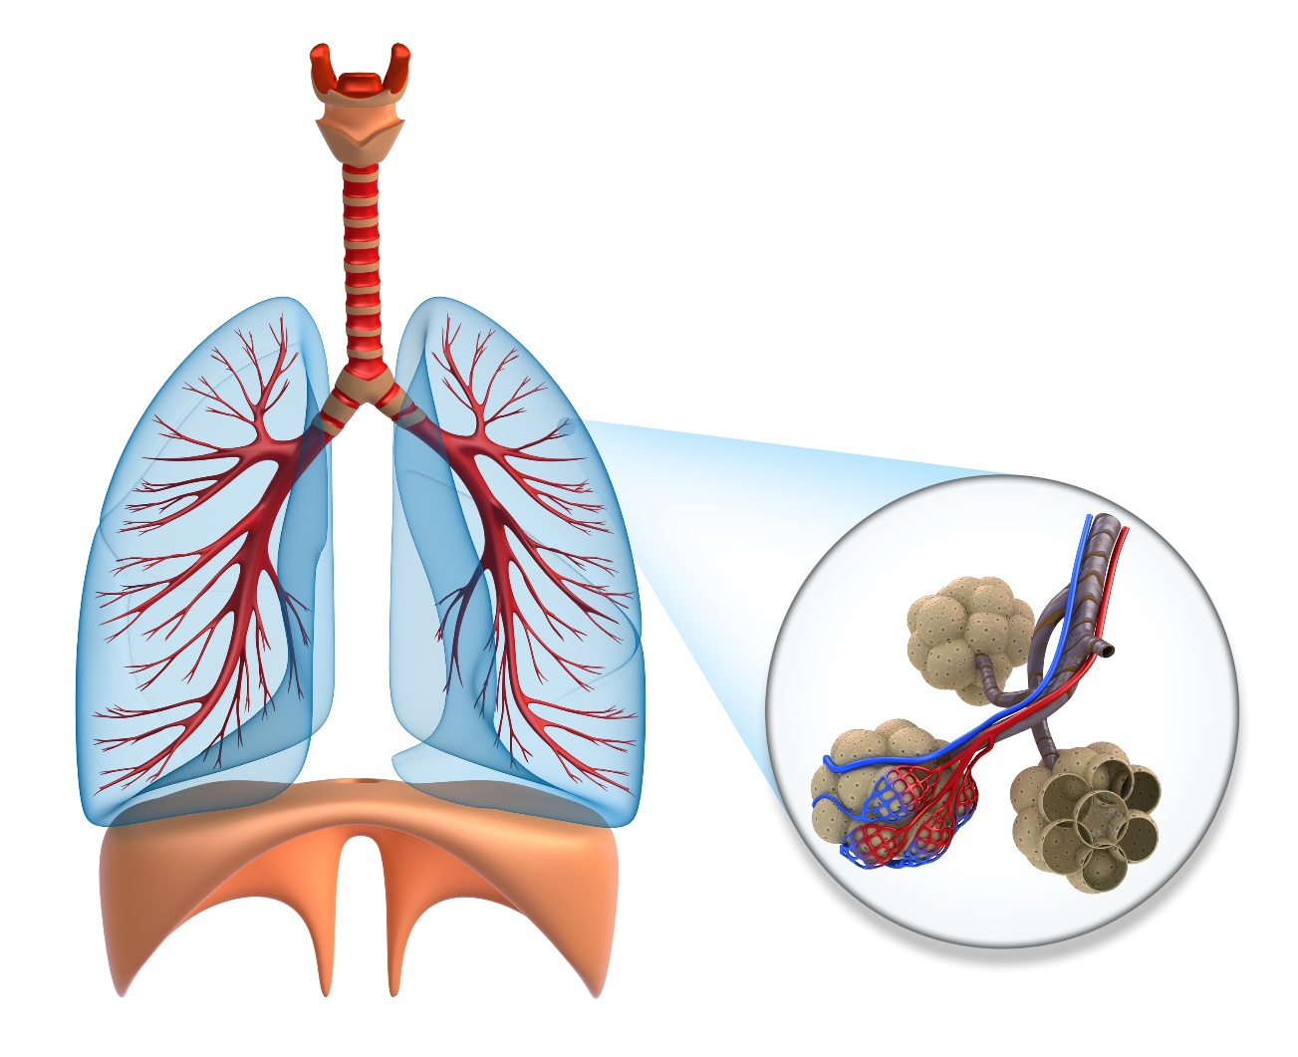

A

B

E

C

D

(a) A: bronchii B: bronchioles C: alveoli D: trachea E: diaphragm

(b) A: bronchioles B: bronchii C: alveoli D: diaphragm E: trachea

(c) A: alveoli B: bronchii C: bronchioles D: diaphragm E: trachea

(d) A: bronchii B: bronchioles C: alveoli D: diaphragm E: trachea

2. Which statement below is true, in relation to diastolic blood pressure?

(a) Diastolic pressure is the lowest pressure and occurs when the heart relaxes to fill with blood.

(b) Diastolic pressure is the highest pressure and occurs when the heart relaxes to fill with blood.

(c) Diastolic pressure is the highest pressure and occurs when the heart pumps blood into the aorta.

(d) Diastolic pressure is the lowest pressure and occurs when the heart pumps blood into the aorta.

3. Which response correctly identifies the characteristics of skeletal muscles?

|  |  |
| --- | --- |
| Characteristic | Description of characteristic |
| A | Muscle are made up of different fibres that contract at different speeds and can generate varying amounts of force |
| B | Muscles have the ability to shorten |
| C | Muscles have the ability to return to their original shape after shortening or lengthening |
| D | Nerve impulses are sent to the required muscles to prompt muscle contraction |
| E | Muscles have the ability to lengthen |

(a) A: fibre types, B: elasticity, C: excitabilty, D: extendibility, E: contractibility

(b) A: fibre types, B: contractibility, C: elasticity, D: excitability, E: extendibility

(c) A: elasticity, B: contractibility, C: fibre types, D: excitability, E: extendibility

(d) A: contractibility, B: elasticity, C: fibre types, D: extendibility, E: excitability

4. Pulmonary circulation involves

(a) circulation of the blood between the heart and body tissue.

(b) blood that is high in concentration of oxygen and low in concentration of carbon dioxide.

(c) blood that is low in concentration of oxygen and high in concentration of carbon dioxide.

(d) circulation of blood between the heart and the lungs.

5. A soccer player, standing directly in front of goals, performs a free kick. The action occurring at the hip during the execution phase of this skill, is best described as

(a) abduction.

(b) rotation.

(c) flexion.

(d) extension.

6. In which of the following actions would the quadriceps muscles be considered the agonist

(a) pointing your toe.

(b) Bending of the knee in breaststroke.

(c) kicking a soccer ball.

(d) catching a basketball.

Question 7 and 8 refer to the following table.

|  |  |  |  |
| --- | --- | --- | --- |
| **Muscle Fibre Type** | **Contraction Speed** | **Fatigue Rate** | **Force Production** |
| Red Fibres | Low | A | B |
| White Fibres | High | C | D |

7. The correct description at A and C would be

(a) A = high, C = low

(b) A = low, C = high

(c) A = low, C = low

(d) A = high, C = high

8. The correct description at B and D would be

(a) B = high, D = low

(b) B = low, D = high

(c) B = low, D = low

(d) B = high, D = high

9. White blood cells are responsible for

(a) fighting infection

(b) transporting nutrients

(c) blood clotting

(d) transporting nutrients

**Short Answer (28 marks)**

**Question 10 (9 marks)**

Breaststroke is a popular swimming style where the swimmer, on their front, performs what is often called a ‘frog’ kick.

(a) With reference to the images below, describe the sequence of movements that occur at the **knee and ankle** during of performance of a breaststroke kick.

(4 marks)

A B C

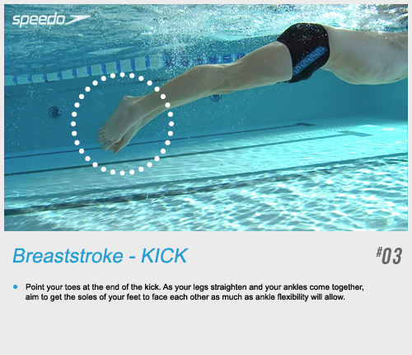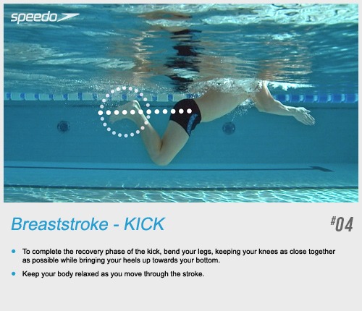1. 2.

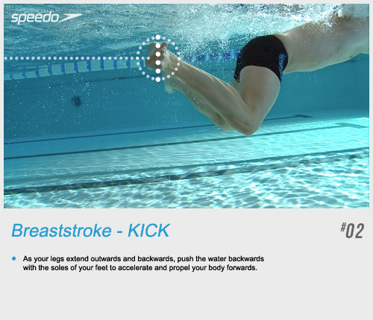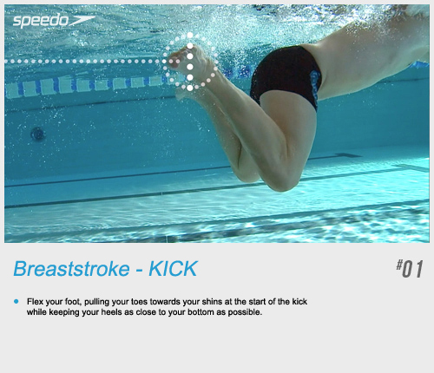4. 3.

|  |  |  |
| --- | --- | --- |
| Description | | Marks |
| Knee | Identifies flexion being shown in images 1 to 3/ flexion is the initial movement  Identifies extension being shown in images 3 to 1/ extension is the final movement | 1 mark  1 mark |
| Ankle | Identifies dorsi flexion being shown in images 1 to 4/ dorsi flexion is the initial movement  Identifies plantar flexion being shown in images 4 to 1/plantar flexion is the final movement | 1 mark  1 mark |

(b) Name the **two** agonist muscles involved in the actions performed in the movement from image 1 to image 2. (2 marks)

|  |  |  |
| --- | --- | --- |
| Description | | Marks |
| Identifies the quadriceps | | 1 mark |
| Identifies the gastrocnemius | | 1 mark |
| Description | | Marks |
| Knee | Identifies flexion being shown in images 1 to 3/ flexion is the initial movement  Identifies extension being shown in images 3 to 1/ extension is the final movement | 1 mark  1 mark |
| Ankle | Identifies dorsi flexion being shown in images 1 to 4/ dorsi flexion is the initial movement  Identifies plantar flexion being shown in images 4 to 1/plantar flexion is the final movement | 1 mark  1 mark |

(b) Name the **two** agonist muscles involved in the actions performed in the movement from image 1 to image 2. (2 marks)

|  |  |
| --- | --- |
| Description | Marks |
| Identifies the quadriceps | 1 mark |
| Identifies the gastrocnemius | 1 mark |

(c) Name the bones in the leg and foot of swimmer labelled as A, B and C in image 1.

(3 marks)

A: _______Tarsals_______________________________

B: ___________Patella___________________________

C: ____________Femur__________________________

**Question 11 (3 marks)**

Identify muscle X, Y and Z in the image of the shot-putter below.

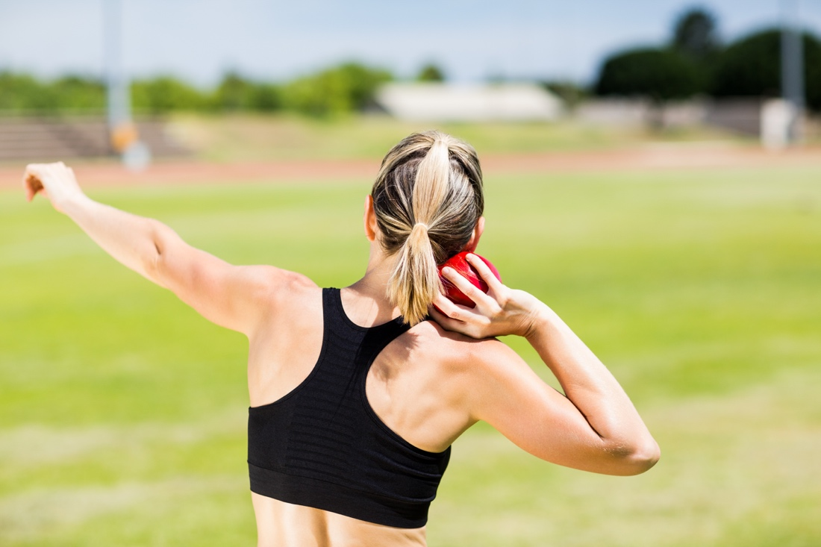

Y

Z

X

X: _____Deltiod________________________________

Y: __Biceps___________________________________

Z: ____Triceps_________________________________

**Question 12 (3 marks)**

Using the diagram below, label the origin and insertion points of the biceps muscle. Label **both** diagrams.

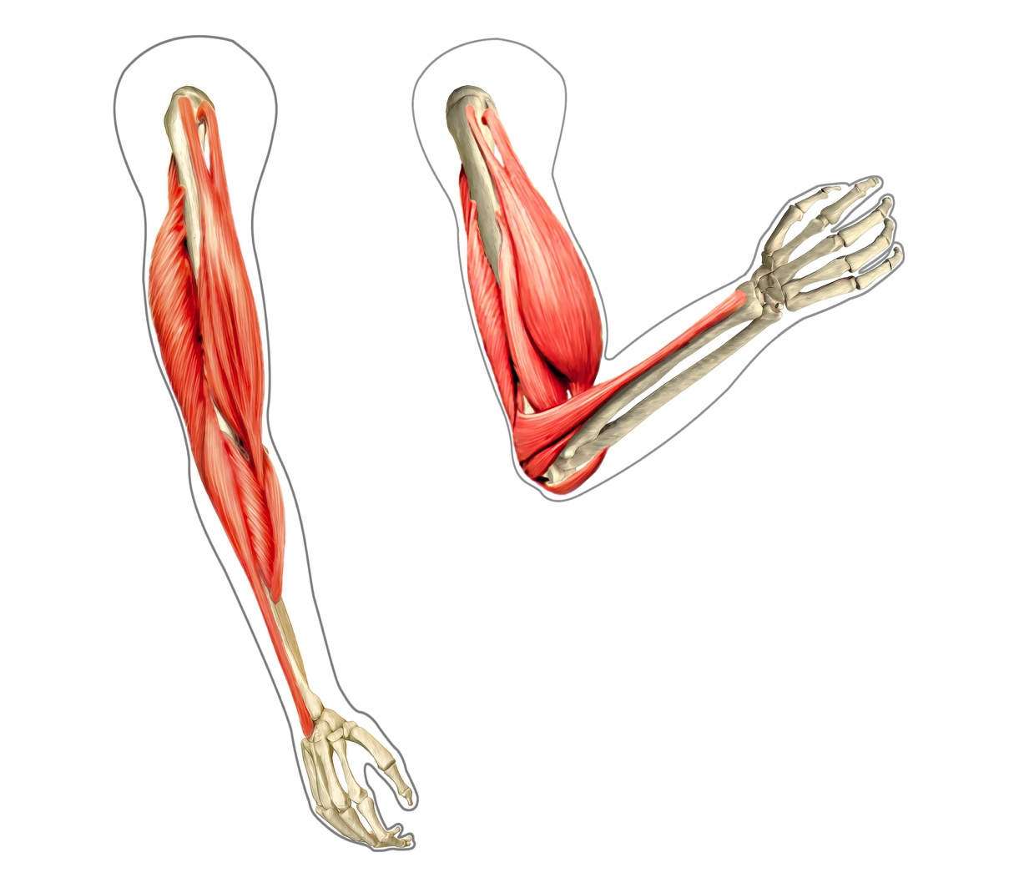

Origin

Insertion

**Question 13 (5 mark s)**

The image below is a representation of a blood vessel showing the three main components of blood. Use the diagram to complete the table.

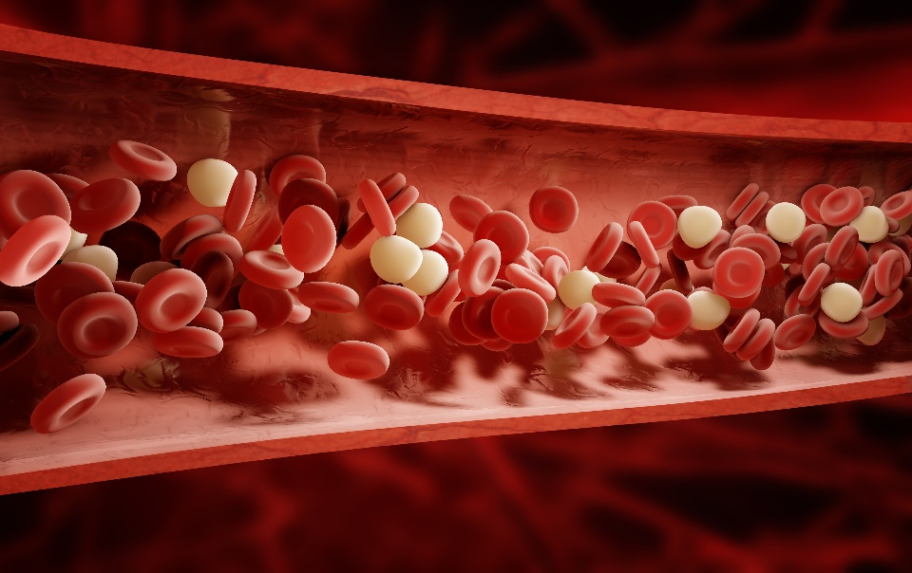

**A**

**B**

**C**

|  |  |  |
| --- | --- | --- |
| Structure | Name | Function |
| A | **Pl**  Plasma  (1 mark) | Liquid component of the blood in which the other cells are suspended. |
| B | White blood cells/white cells  (1 mark) | Infection control/ fight infection/destroy bacteria  (1 mark) |
| C | Red blood cells/red cells  (1 mark) | Transport of nutrients/ transport of oxygen, carbon dioxide and waste  (1 mark) |

**Question 14 (4 marks)**

Explain the changes that occur in pressure and volume within the lungs as the diaphragm contracts and lowers. What effect does this have on airflow through the mouth and nose?

|  |  |
| --- | --- |
| Description | Marks |
| Diaphragm lowers causing an increase in volume. | 1 mark |
| Increased volume causes a decrease in pressure. (Must refer to change in volume causing the change in pressure) | 1 mark |
| Results in low pressure inside lungs and high pressure outside lungs | 1 mark |
| Air is forced in through the mouth and nose | 1 mark |

**Question 15 (4 marks)**

There are two main types of muscle fibres, fast-twitch fibres and slow-twitch fibres. The percentage of fast-twitch fibres compared to slow-twitch fibres that an athlete has depends of the characteristics of the individual and their training.

1. Give **one** example of a type of athlete you would expect to have a significantly higher percentage of fast twitch fibres and **one** example of a type of athlete you would expect to have a significantly higher percentage of slow twitch fibres.
2. For each athlete define the **ratio** of fast twitching muscle fibres compared to the slow twitching muscles fibres.

|  |  |
| --- | --- |
| Description | Marks |
| High percentage fast twitch fibres: weightlifter, sprinter.  Or other reasonable response b) 80% fast 20% slow | 1 mark |
| High percentage slow twitch fibres: Endurance athlete, marathon runner. Or other reasonable response b)80% slow and 20% fast | 1 mark |

**Extended Answer (10 marks)**

**Question 16 (10 marks)**

The image below shows gas exchange taking place at the alveoli in the lungs. For this to occur there must be a concentration gradient; a difference in concentration across a membrane. Discuss how gas exchange in the lungs occurs and how the structure of the lungs allows this to take place efficiently.

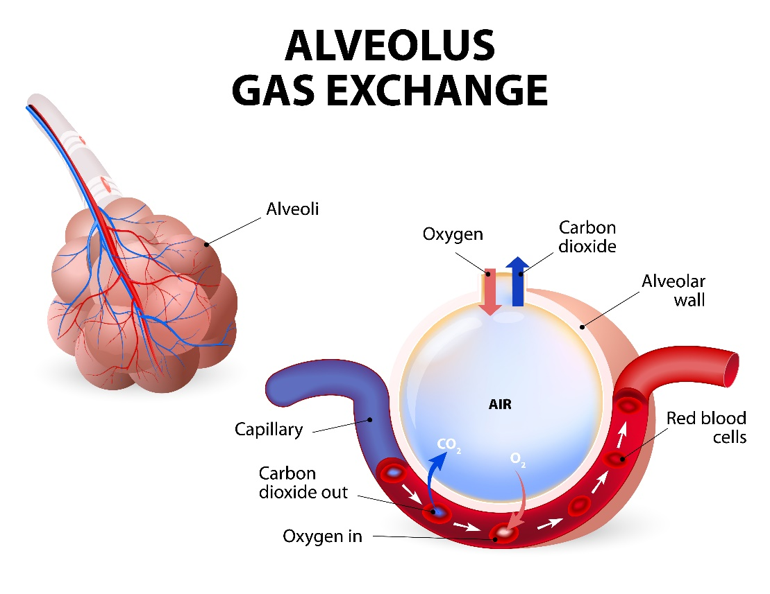

|  |  |
| --- | --- |
| Description | Marks |
| During inhalation oxygen enters the alveoli | 1 mark |
| Venous blood/deoxygenated blood travels through the capillaries that run past the alveoli | 1 mark |
| The blood flowing past the alveoli is low in oxygen concentration/pressure | 1 mark |
| Oxygen concentration/pressure inside the alveoli is higher | 1 mark |
| Gasses move from area of high pressure to area of low pressure | 1 mark |
| Oxygen diffuses from the alveoli into the blood | 1 mark |
| The blood flowing past the alveoli is higher in carbon dioxide concentration/pressure than inside the alveoli | 1 mark |
| Carbon dioxide diffuses from the blood into the alveoli | 1 mark |
| Diffusion can occur due to the walls of the capillaries and alveoli being only one cell thick | 1 mark |
| Alveoli are very tiny and provide a large surface area for efficient gas exchange | 1 mark |